# Express.JS Regular Exam – Expense Tracker

## Exam rules:

1. You have 4 hours
2. When you are ready, delete the ***node_modules***folder, make sure all dependencies are listed in the ***package.json*** file and submit your archived project.
3. You are provided with **HTML & CSS** resources, which you can **modify**
4. Use **Express.js** as a back-end framework
5. Use **MongoDB** as a database with **mongoose**
6. You can use whatever **view engine** you like (Handlebars, EJS, Pug etc.…)

## Application Overview

Get familiar with the provided **HTML & CSS** and create an application for **tracking expenses**.

## Functional Requirements

The Functionality Requirements describe the functionality that the **Application** must support.

### Guest (not logged in)

The **application** should provide Guest (not logged in) users with the functionality to login, register and **view** the Home page.

### Users (logged in)

The **application** should provide **Users** (logged in) with the functionality to:

* **View all the created expenses for the currently logged in user**
* **Create new expenses**
* **Access expense report page**
* **Access** **account information page**
* **Logged in users also should can be able to refill their bank accounts**

## Database Models (10 pts)

The **Database** of the Expence Tracker application needs to support **2 models**

### User

* Username - string (required), unique
* Password - string (required)
* **Amount – number, (required), default 0**
* **Expenses – a collection of Expenses**

### Expense

* **Merchant - string (required),**
* **Total – number (required),**
* **Category – string (required),**
* **Description – string (required), minimum 3 characters, maximum 30 characters**
* **Report – boolean (required), false by default**
* **User – Reference to the User model – creator (required)**

Implement the entities with the **correct datatypes**.

## Application Pages (70 pts)

### Guest Pages (15 pts)

These are the pages and functionalities, accessible by **Guests (logged out users).**

#### Home Page (logged out user)

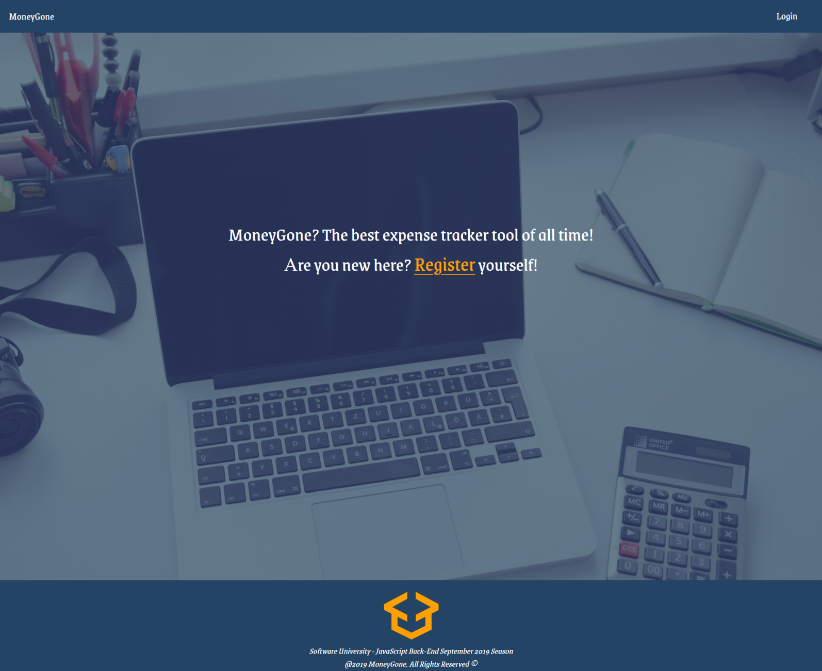

#### Register Page (logged out user)

Register a user inside the database with **username**, **password** and starting amount money. Both **passwords** must **match**! After successful registration **redirect to home page**.

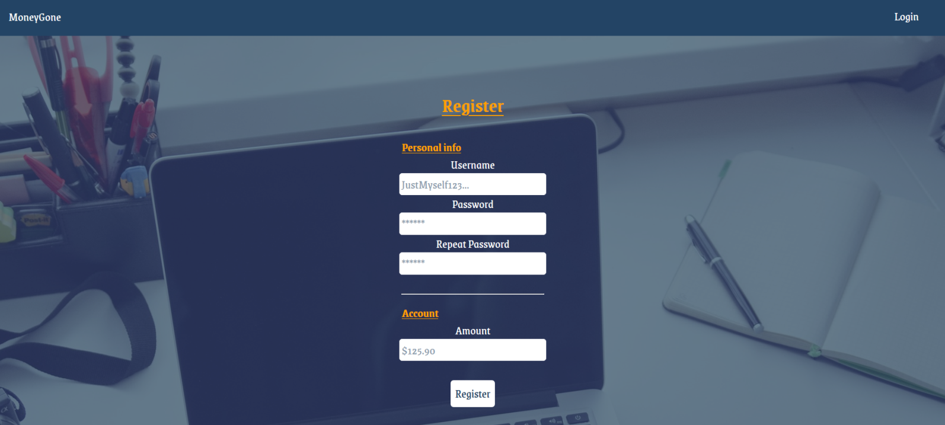

#### Login Page (logged out user)



### User Pages (55 pts)

These are the **templates** and **functionalities**, accessible by Users (**logged in** users).

#### Home Page (logged in user)

List all **expenses which are created by the currently logged in user**. If some expense **has** the **report** **check** while creating, the [**Report**] **button** should be visible and should refer to the report.

The format for each expense is the following:

|  |  |  |  |
| --- | --- | --- | --- |
| Merchant + Report (Optional) | Amount | Category | Description |

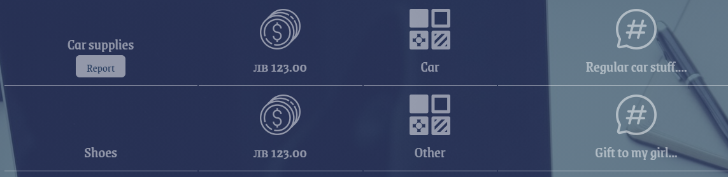

**Hint: Use the provided pictures to achieve the effect shown.**

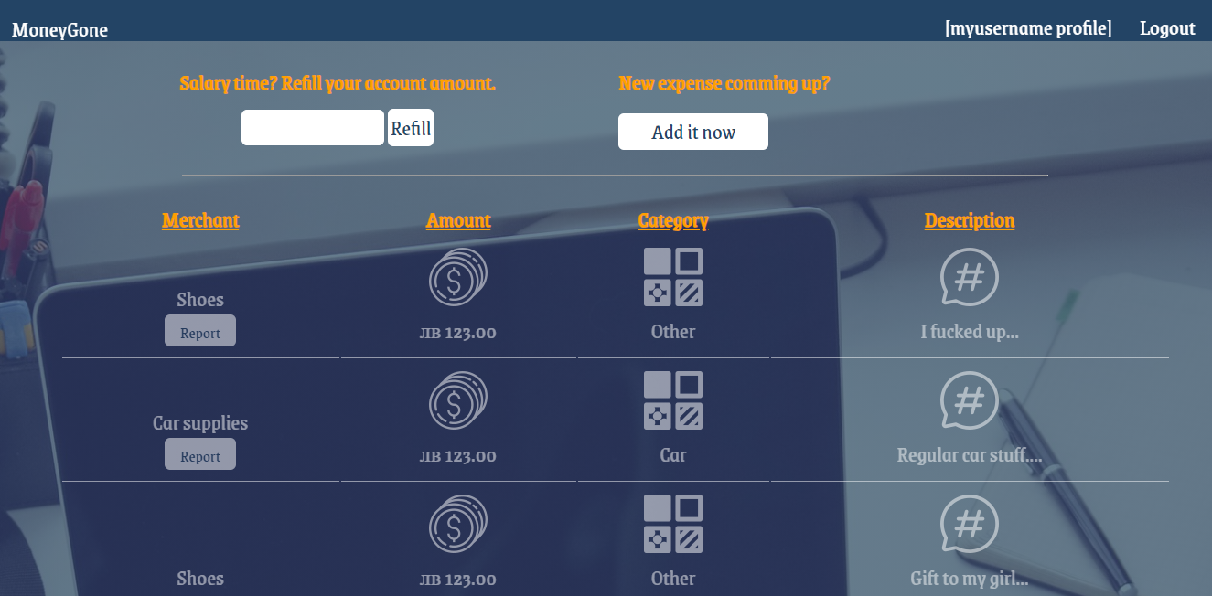

If there are no expenses in the database which the currently logged in user is created, display **"No expenses founded so far... GOOOD JOB!"**

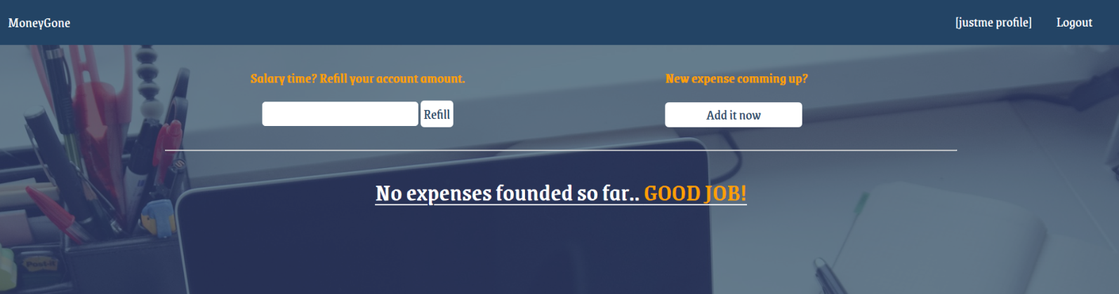

#### Create New Expense Page (logged in user)

Enter **Expense**: **merchant**, **total, category, description** and choose **report** for the expense. You will receive the value of the checkbox as a string **"on"** if it's checked or **undefined** if it's not. You must convert the received value as Boolean **true** or **false** and save the expense in the database.

**Report check** will allow the current expense to be **accessed**, something like details page called **report expense page**.

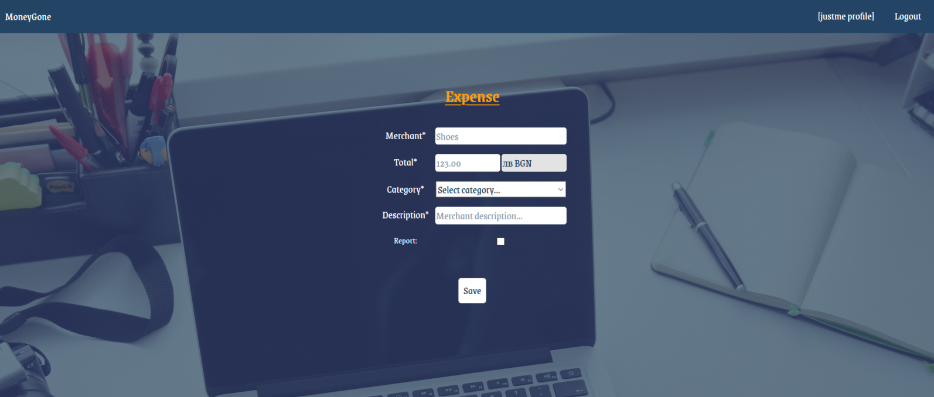

#### Logged in Expense Report Page (logged in user)

The report page is accessed by clicking over the [**Report**] **button's** expense (if any) and there are shown the expense's **id**, **category**, **amount**, **merchant**, **description** and **[Stop tracking]** **button** (if the check while creating the current expense was checked)

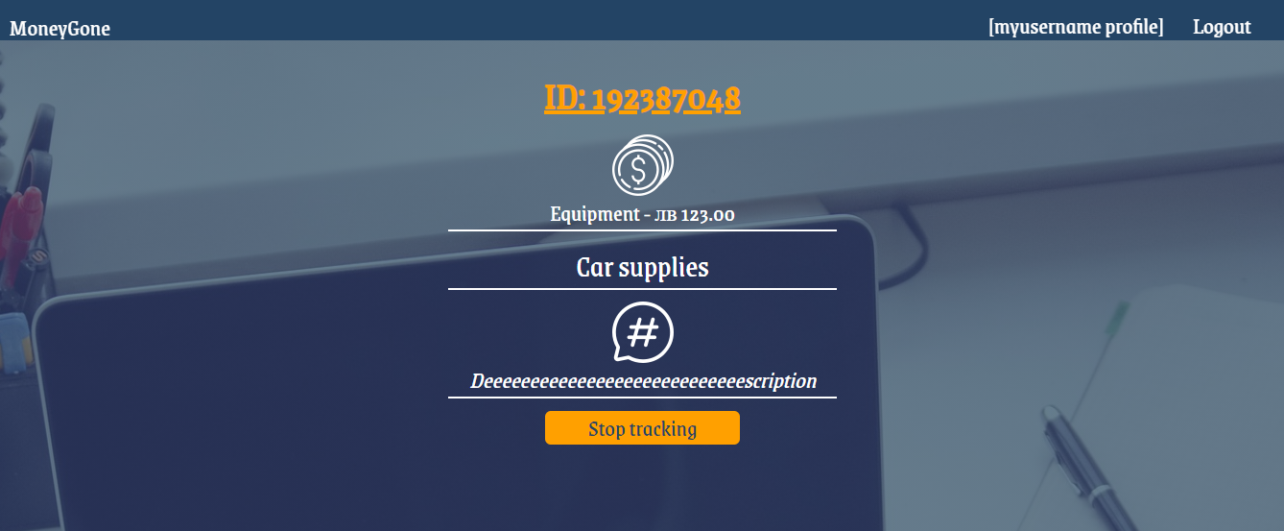

##### Stop tracking

Clicking over **[Stop tracking] button** the current expense should be **deleted** from the database and the user should be **redirected** to **all his expenses**.

#### Refill action (logged in user)

The input field in the home page (where all user expenses are listed) with label "**Salary time? Refill your account amount.**" Is form which can **increase (EDIT)** the current user account amount.

##### Before refill

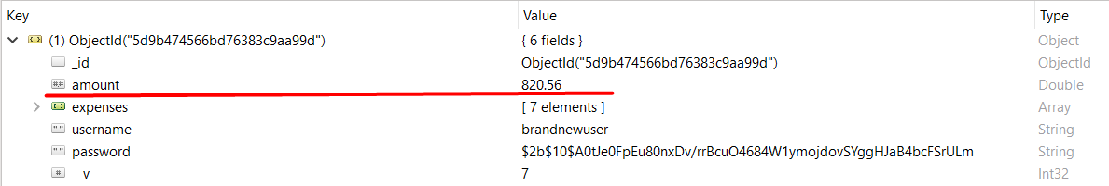

##### Refilling



##### After refill:

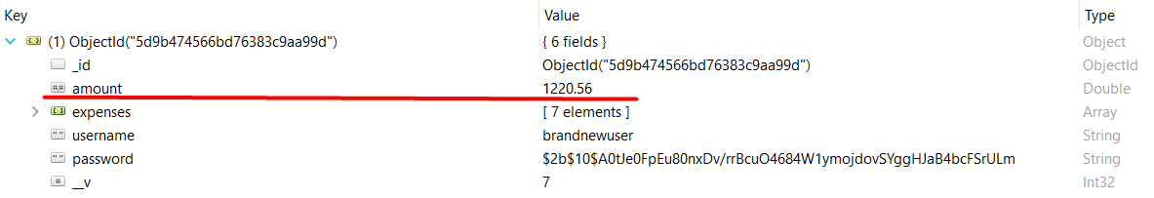

## Security Requirements (10 pts)

The Security Requirements are mainly **access** requirements. Configurations about which users can access specific functionalities and pages.

* Guest (not logged in) users can access Home page (where users can register and login)
* Guest (not logged in) users can access Login page and functionality
* Guest (not logged in) users can access Register page and functionality
* Users (logged in) can access Expenses page (Listed all expenses for the currently logged in user) page and functionality
* Users (logged in) can access **Expense** Report page and functionality (if while creating the current expense the report check was selected)
* Users (logged in) can access **Create Expense** page and functionality
* Users (logged in) can acces to Refill Account Amount functionality in the home page
* Users (logged in) can acces to Account/Profile page
* Users (logged in) can access Logout functionality

Any **invalid** route like **localhost:3000/hxauhxuahxuahxuahxuahxuha** should show the following view  


## Validation and Error Handling (10 pts)

The application should notify the users about result of their actions.

### Login / Register

You should make the following validations:

* The **username** should be **at least 4 characters** long and should consist only **english** **letters** and **digits**
* The **password** should be **at least 4 characters** long
* The **repeat password** should be **equal to the password**
* The **account amount**  should be **positive** **number**, which by **default** the value is **0** if while registering the user don't fill the field

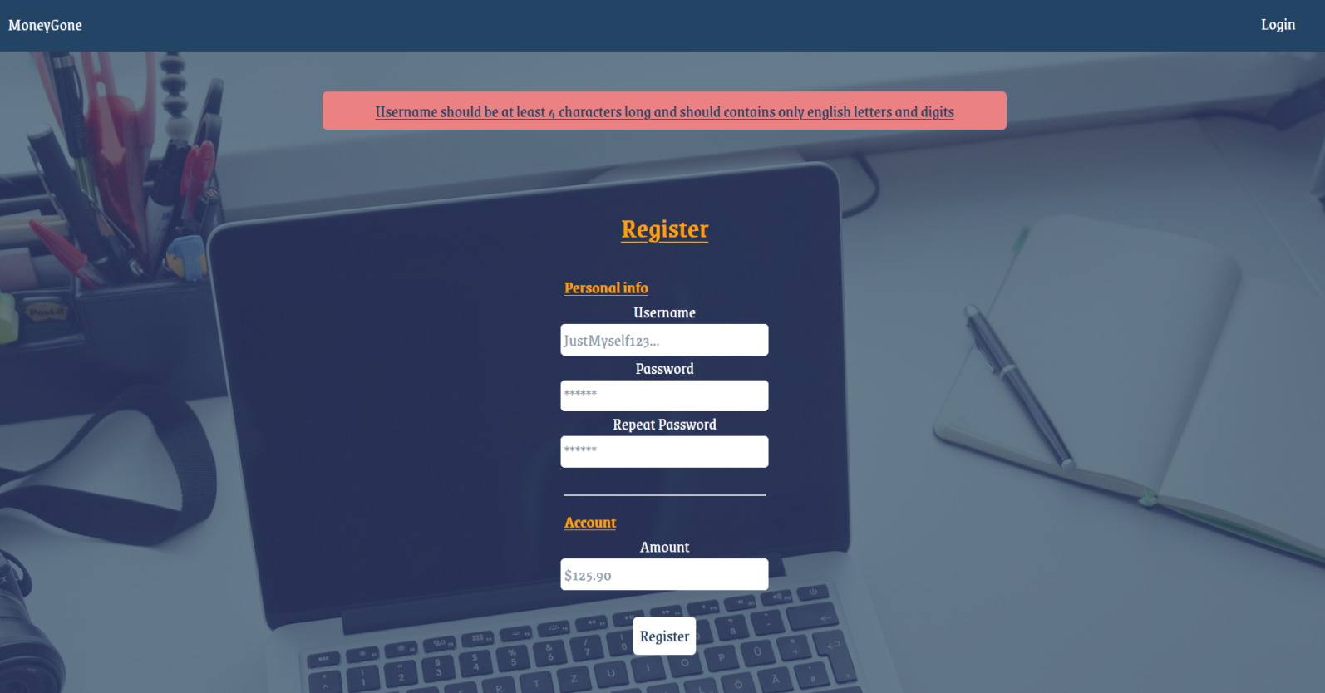

### Expense

You should make the following validations while **creating** expense:

* The **merchant** should be **at least 4 characters** long
* The **total** should be **positive** **number**
* The **category** should one from the given options
* The **description** should be minimum 3 **characters** long and **30 characters** maximum

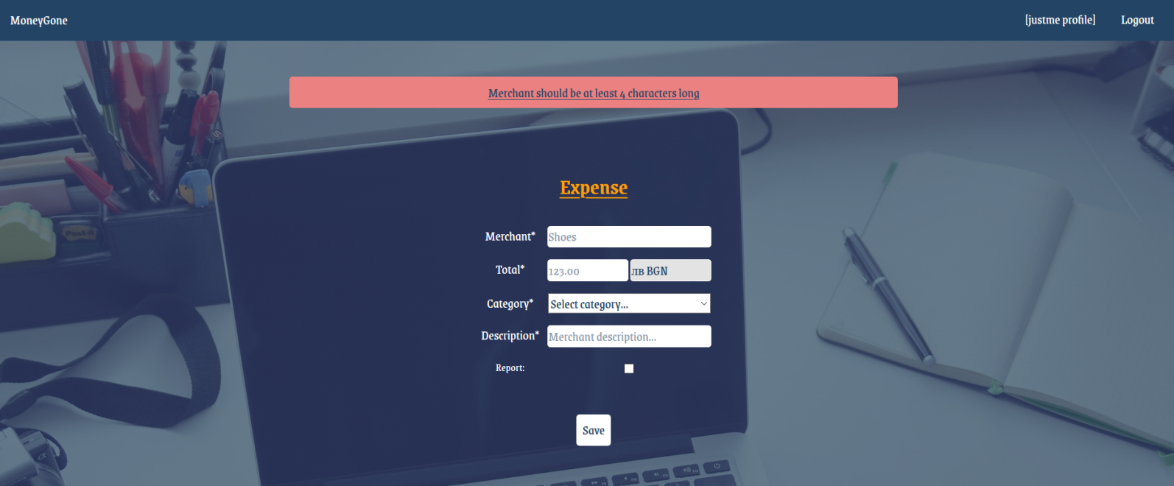

## *Bonus (10 pts)

#### Account info / User profile page

The account / profile page accessed by the navigation section **[{user} profile]**, should show the **total** **amount** of **all expenses** for the user, **total** **merchants** and the **available** **account** **amount** on the current user.

